MedHub Resident Workflow Guide
This workflow guide provides residents with step-by-step instructions for using MedHub, including logging in, completing work hours, and requesting vacation or sick time.
1. Introduction to MedHub
- Log in to MedHub using the link sent to your HHC Outlook email.
- Once logged in, locate the Help button in the upper right corner.
- Click Launch Learning Portal.
- Select Resident Courses.
- Review the learning modules: Resident Foundation and MedHub Mobile App.
2. Logging Work Hours in MedHub
Important: Work hours are due in MedHub by 7:00 AM every Monday.
- From the homepage, click This Week’s Work Hours under the Tasks section.
- Ensure you are on the Weekly Work Hours tab.
- Confirm the correct week is selected and that 'By Current Week' is selected.
- Navigate to the appropriate day of the week.
- Click and drag to enter your work periods.
- Click Save and Submit.
3. Requesting Vacation or Sick Days
Note: Absences cannot be submitted using the MedHub Mobile App.
- On the left side of the homepage, scroll to the Request Forms section.
- Click Absence/Vacation Request Forms.
- Select either the Vacation or Sick Days tab.
- Enter the requested date range.
- Click Send Request.
- Your Program Coordinator (Sarah) will review and approve the request.
- To review the status of your vacation requests view the Vacation Request History section on the right side.
Quick Reminders
- Check MedHub regularly for pending tasks and evaluations.
- Submit work hours weekly before the Monday deadline.
- Request planned vacation time as early as possible.
- Complete onboarding learning modules during orientation.

Introduction to Medhub
Step 1: Log in to MedHub using the link sent to your HHC Outlook email.
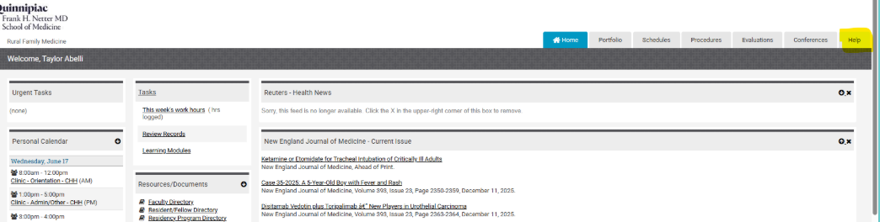Step 2: Once logged in locate the help button in the upper right corner.

Step 3: Click launch learning portal
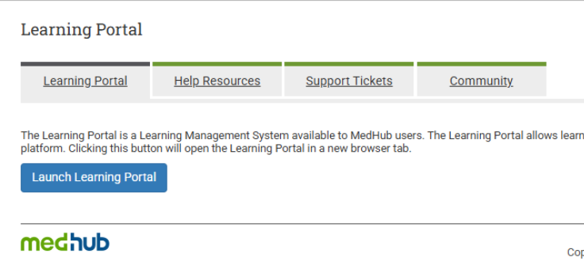
Step 4: Click Resident Courses:

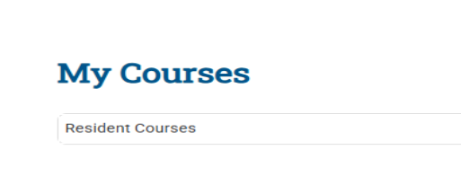
Step 5: Review the learning modules Resident Foundation and Medhub Mobile App.
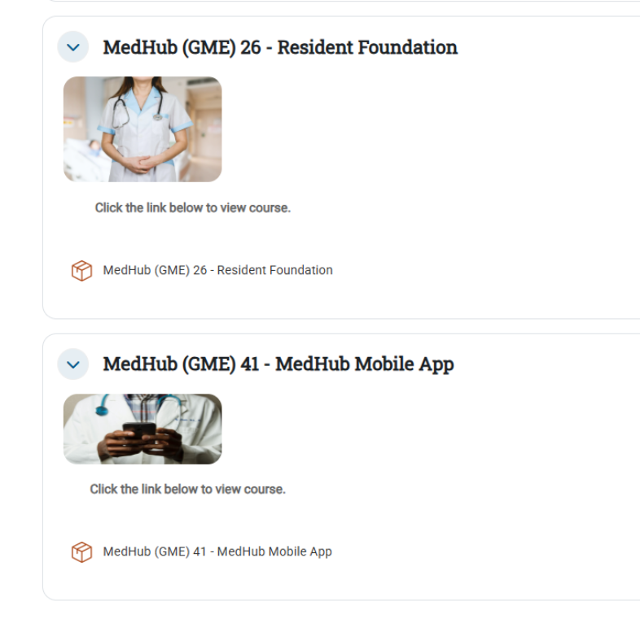

Absence Requests in Medhub

** Note: Absences cannot be submitted using the MedHub Mobile App.
Step 1: On the left side of the home page scroll down to the Request Forms box-
Click Absence/Vacation Request Forms
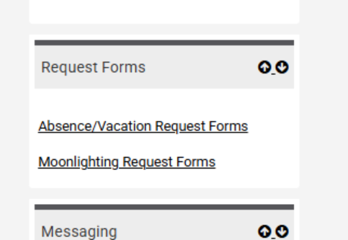
Step 2: Pick either the vacation or sick days tab to enter the time off.
Once the date range is filled click send request. From there your Program Coordinator (Sarah) will review /approve your vacation.
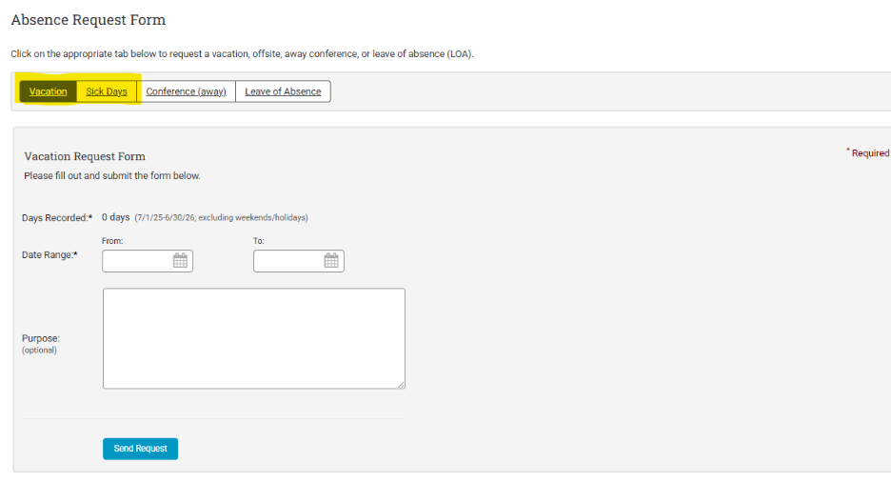
Step 3: Reviewing vacation request history
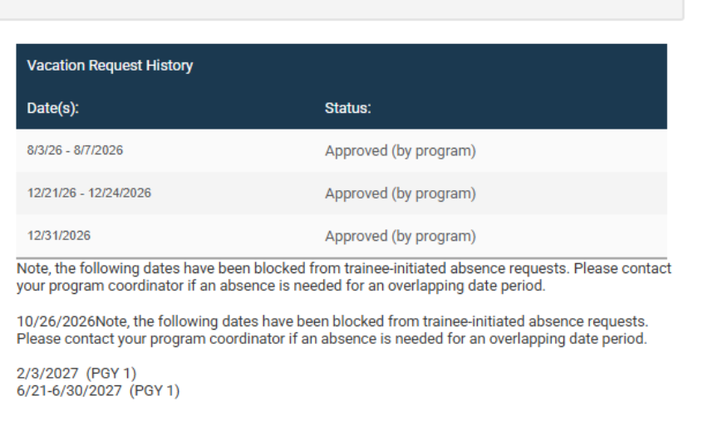

Logging Work Hours in Medhub
** Work hours are due in Medhub by 7:00am on Monday mornings
Step 1: Click the This week’s work hours under the Tasks section on the home page
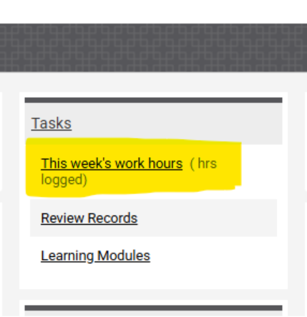
Step 2: Make sure you are on the Weekly Work Hours Tab
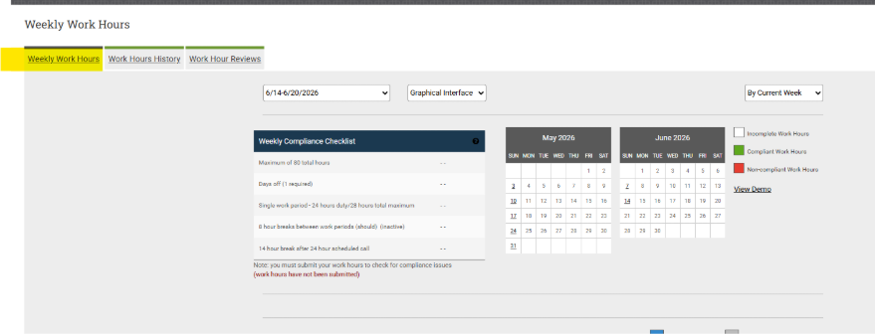
Step 3: Make sure the correct week is selected, and “By Current Week” is selected
Step 4: Go to the day of the week then click and drag your work periods
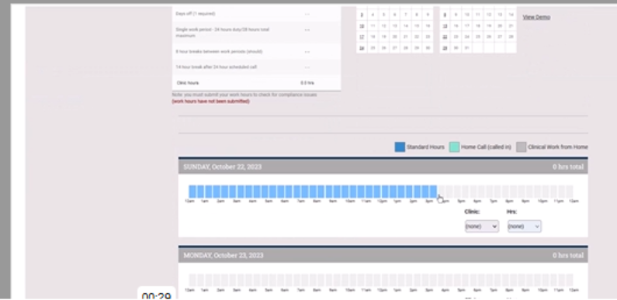

Step 5: Click save and submit

